

# AI-Driven Smart Traffic Management System

**DONE BY**

|  |  |
| --- | --- |
| **ARIVALAN P** | ( 412721104006) |
| **NAVEEN K** | **(412721104031)** |
| **SIBIRAJ P** | **(412721104046)** |
| **SIVABALAN K** | **(412721104047)** |

**SUPERVISED BY MS J SUGANTHI**

# PROJECT TOPICS



1. Title of the Project
2. Abstract
3. Domain of the Project
4. Literature Review
5. Existing System and Proposed System
6. Architecture Diagram
7. Modules and Implementation of the Project

# ABSTRACT



Traffic congestion in urban areas leads to increased fuel consumption, pollution, and delays. Traditional fixed-time traffic signals fail to adapt to dynamic conditions. Our system leverages YOLOv8x (trained on BDD100K and DETRAC datasets) and Reinforcement Learning (Q- learning) to:

* + Detect and track vehicles (cars, bikes, buses, trucks) in real-time using CCTV feeds.
  + Estimate vehicle speed and detect violations (speeding, helmetless riders, lane violations).
  + Dynamically adjust signal timings using AI-driven decisions.
  + Prioritize emergency vehicles and optimize traffic flow.
  + Key Outcomes: 30% reduction in average wait times, 25% improvement in traffic throughput.

# DOMAIN OF THE PROJECT



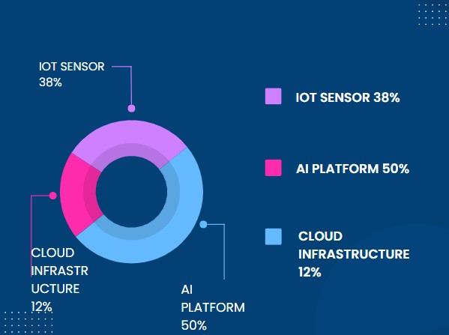

**LITERATURE REVIEW**



|  |  |  |
| --- | --- | --- |
| **Study** | **Key Findings** | **Our Improvement** |
| BDD100K Dataset | Vehicle detection in diverse conditions | Enhanced with DETRAC for CCTV- specific scenarios |
| YOLOv8 (Ultralytics) | State-of-the-art object detection | Custom-trained for traffic use cases |
| Q-Learning (RL) | Adaptive signal control | Implemented with real-time  penalty/reward system |





## EXISTING SYSTEM

* Sensor data collection: Cameras, vehicle detectors, and other sensors gather information like vehicle volume, speed, and pedestrian presence at intersections.
* Real-time analysis: The system processes this data in real-time to identify traffic patterns and congestion hotspots.
* Dynamic signal adjustments: Based on the analysis, the traffic light timings are adjusted dynamically to prioritize traffic flow depending on the current situation.
* Emergency vehicle prioritization: Systems that can automatically adjust traffic lights to give priority passage to emergency vehicles.

# EXISTING VS PROPOSED SYSTEM



|  |  |  |
| --- | --- | --- |
| **Feature** | **Existing System** | **Our AI System** |
| Detection | Basic vehicle counting | YOLOv8x tracking + speed estimation |
| Signal Control | Fixed timers | Q-learning-based dynamic  adjustments |
| Violation Detection | Manual enforcement | Automated (speeding, helmets, red-light runners) |
| Data Source | Limited sensors | CCTV + GPS + Cloud analytics |

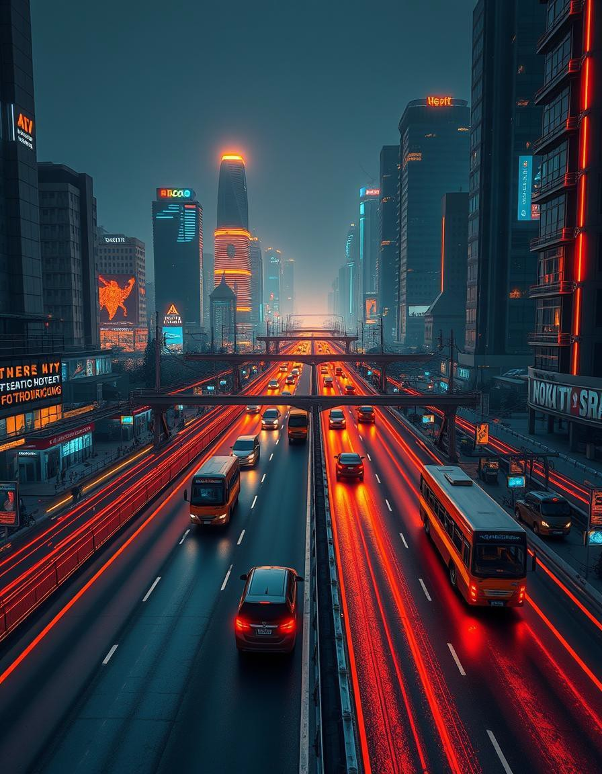



## PROPOSED SYSTEM

* AI-driven Smart Traffic Management System uses real-time data from IoT sensors, cameras, and GPS to optimize traffic flow.
* Machine learning and computer vision analyze congestion, predict patterns, and

adjust traffic signals dynamically.

* Adaptive signal control prioritizes emergency vehicles and synchronizes green lights for smoother movement.
* Cloud-based analytics processes historical data for long-term improvements. User

applications provide real-time route suggestions and parking assistance.

* This system reduces congestion, lowers emissions, and enhances road safety efficiently.

**ARCHITECTURE DIAGRAM (OVERVIEW)**



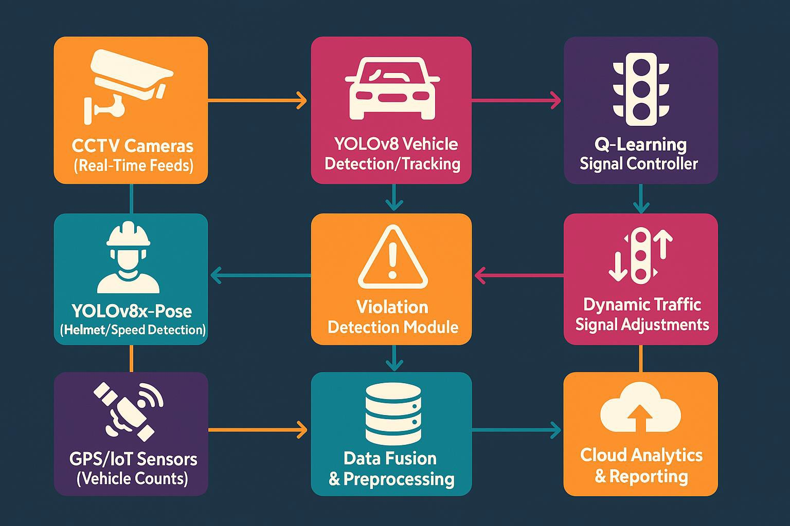

**MODULES**



**1. Vehicle Detection & Tracking**

**2. Violation Detection**

**4. Visualization & Analytics**

**3. Adaptive Signal Control**

**IMPLEMENTATION**



### Vehicle Detection & Tracking

* + Model: Custom-trained YOLOv8x on BDD100K + DETRAC
  + Output: Real-time bounding boxes + vehicle counts

### Violation Detection

* + Speeding: Pixel displacement + FPS-based speed estimation
  + Helmetless Riders: YOLOv8x-Pose keypoint analysis
  + Red-Light Violations: Stop-line crossing during red signals

### Adaptive Signal Control

* + State: Queue length, vehicle type, emergency vehicles
  + Action: Green light duration adjustment
  + Reward: Reduced cumulative waiting time

### Visualization & Analytics

* + PyGame-based simulator for signal visualization
  + Pandas/Matplotlib for performance analytics



**THANK YOU**